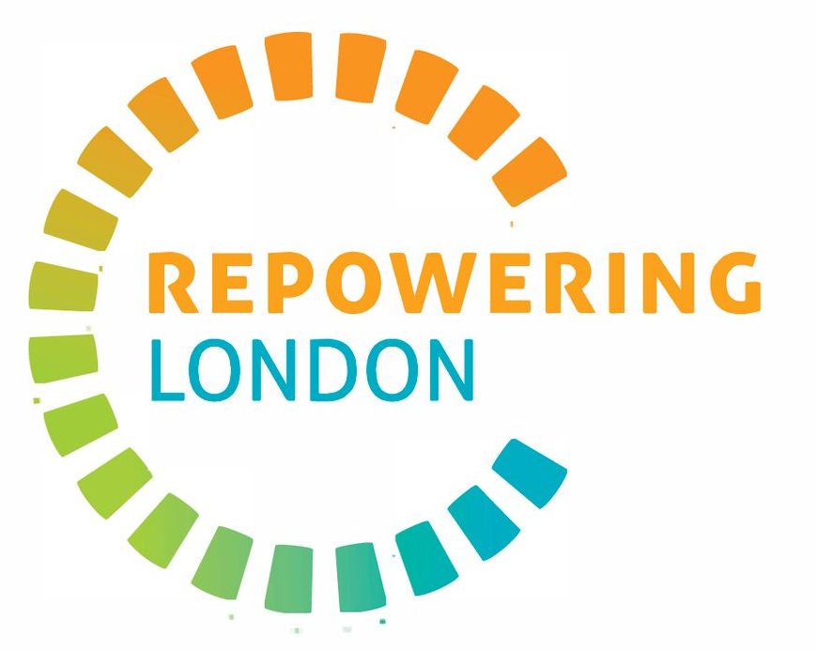

Westminster Community Lead
Salary: £11,660 for 2 days/week (e.g. £29,150 FTE).
Contract: Part-time, 2 days a week. Probation period of 3 months.
Location: Working in-person in Westminster and from home, with option to work at Repowering London’s office in Brixton.
Deadline to apply: 23.59 on 24 August 2026.

About the role
This is an exciting opportunity for someone with strong links to Westminster who cares about tackling climate change locally and leading their borough towards a more inclusive and sustainable future.
As a Community Lead in the Westminster borough, you will have two main objectives: to bring to life Westminster's first community energy group and help it grow into a lively and vibrant co-op, and to run community outreach activities around energy efficiency, solar development and community ownership. You will be employed by Repowering London and work together with our North London Project Manager.
We are looking for a Westminster resident with a strong network in the local communities, and an interest in community organising.
As a Community Lead, you will:
- Gain valuable work experience, join a motivated team, boost your confidence and grow your network;
- Learn about and dive deep into community energy, support with energy bills, community engagement methods and community-led domestic retrofit;
- Contribute to a fairer, more local way of creating and distributing energy in your borough.

About Repowering London
Repowering London is an award-winning social enterprise developing clean energy for urban communities. A community development organisation, we enable local communities to plan, fund, build and benefit from clean energy and energy efficiency projects across buildings. We help people see how they can make a real difference.
We are the UK's most experienced urban community energy innovator with a successful track record of working in partnership with major London councils and national funders for the last ten years.
Our vision is for every town and city in the UK to benefit from locally owned clean energy solutions. We believe that urban buildings can be transformed into intelligent, efficient, clean power hubs, providing substantial economic, social and environmental benefits. Energy security can become the norm, and inequality and fuel poverty a thing of the past. As a place to work, Repowering London has a strong culture of personal respect and integrity. We have a talented and diverse team, and we have all made the choice to be part of positive solutions to the collective challenges we face. We aim to create a supportive and empowering working environment, with high levels of collaboration, team support, and personal and professional development.

Job description
Help establish and grow Westminster's first community energy group
- Build links and local partnerships with a wide range of groups and actors in the local community, such as associations, faith-based groups, environmental organisations, voluntary organisations, charities, youth or elderly clubs, community hubs, local businesses and more.
- Identify, recruit and support local residents who are interested in community ownership and taking action on climate change to join the community energy project as directors and volunteers of the new co-op.
- Support the process of co-designing the co-op with volunteers and members to ensure it reflects the needs and aspirations of the local community.
- Attend regular events, meetings, meet-ups, and activities with volunteers and community stakeholders to raise awareness of community energy and how it links with local movements.
- Build strong relationships with co-op directors and volunteers to co-create and run community events, campaigns, and activities.
Outreach and engagement around local energy efficiency and solar development
- Help to design and deliver an outreach programme to engage residents to raise awareness about energy efficiency, particularly within a block of flats.
- Deliver engagement activities around energy efficiency and solar power such as workshops, webinars, and “energy parties”.
- Identify Westminster sites to install solar panels; reach out to and build relationships with site owners.
- Refer local residents who are living in fuel poverty to relevant services.
- Assist with other duties within the scope and nature of the position and in other areas of the business when required.

Person specification
Repowering London will provide training and mentorship to enable anyone with the right learning and passion to develop on-the-job. This role will require an enhanced DBS check.
We will be looking for and assessing candidates on these:
- Westminster resident and/or with very strong demonstrable connections in the borough.
- Strong network of local contacts in Westminster and knowledge of the area.
- Interest in community organising and/or energy justice issues.
- Ability to work flexibly, to attend community events on some evenings and weekends.
- Ability to work in-person in Westminster on a regular basis (with specific arrangements to be agreed together).
These are not essential for this role, but would be useful:
- Experience working or volunteering in/with community groups.
- Ability to work independently and remotely in an unstructured environment; uses initiative to achieve targets.
- Is empathetic, outgoing, and open-minded in diverse environments; enjoys inspiring and encouraging people.
- Good verbal and written communication skills and is comfortable with speaking in public.
- Familiarity with Microsoft tools or similar.
Repowering London’s Employee Value Proposition
At Repowering London, we want everyone to feel valued and to have the opportunity to develop skills and experience. We offer a supportive and flexible working environment, and work-based training to support you in your role.
Skills development is not just limited to your role at Repowering London, and as an organisation we want to support employees to pursue opportunities outside of work which will broaden skills and networks. We recognise that everyone has responsibilities and interests outside of work, whether it is caring for family, studying, volunteering or taking time out. Our Volunteering Policy and Study Leave Policy provide scope for ad-hoc, short-term arrangements to these ends.
Our Flexi Time Policy and Unpaid Leave Policy provide options for those who need to take time away from work for an extended period. We operate a Time Off in Lieu policy for any evening or weekend work.

Position details
You will be employed by Repowering London as the Westminster Community Lead.
You must have the right to work in the UK.
Contract: Part-time, 2 days a week. Probation period of 3 months.
Duration: 18 months starting from September 2026, with possibility of extension.
Hours: 15 hours/week; flexible working hours and evening/weekend work will sometimes be required.
Location: Working in-person in Westminster and from home, with options to work at Repowering London’s office in Brixton.

How to apply
Please email your CV and cover letter to chris.born@repowering.org.uk by 23.59 on 24 August 2026. We will hold interviews for shortlisted candidates from the week of 31 August 2026.
In your cover letter, please address the following questions:
- What are your favourite things about communities in Westminster?
- Tell us about a community that you are part of (this could be an organisation, a community group or network or an informal community such as a neighbourhood or school community).
- Why are you interested in working with Repowering London?
If this process is a barrier to applying, please get in touch to discuss alternative options. We will acknowledge all applications for the role.
We reserve the right to end the recruitment process early.
Repowering London is committed to providing equal opportunities for all applicants regardless of their background. We value diversity and recognise that accessing employment has different challenges for different people. We also know that some voices and perspectives are particularly underrepresented in the environment and energy sectors. We encourage applications from Black, Asian and minority ethnic people; people who identify as having a disability; people from the LGBT+ community; and people who identify as working class (or have done in the past).
If you would like to have an informal chat before applying, please get in touch – we would be very happy to talk to you!

